INDEX

Chapters Topics Page No.

CHAPTER 1: INTRODUCTION AND OBJECTIVE 1-3

1.1 Introduction

1.2 Project Profile

1.3 Objectives

1.4 Existing Manual System

1.4.1 Limitations of the Existing Manual System

1.5 Proposed System

1.5.1 Advantages of Proposed System

CHAPTER 2: REQUIREMENT ANALYSIS 4-5

2.1 Introduction

2.2 Software Requirement

2.3 Hardware Requirement

2.4 Training Requirement

2.5 Descriptions

2.6 Why C++?

2.7 What is Turbo C++?

2.8 What is Dev C++?

CHAPTER 3: FEASIBILITY STUDY 6-6

3.1 Introduction

3.2 Technical Feasibility

3.3 Economical Feasibility

3.4 Operational Feasibility

3.5 Conclusion

CHAPTER 4: CODING AND OUTPUT 6-57

4.1 Coding
4.2 Output

CHAPTER 5: CONCLUSION 58-58

5.1 Future Scope of the Project
CHAPTER 1: INTRODUCTION AND OBJECTIVE

1.1: Introduction:
The project aim to develop a suite of four games using C++ programming language. These games include:
1.Memory Game: A number guessing game utilizing two-dimensional arrays containing
Randomly generated numbers in pairs hidden inside boxes.
2. Cross ‘N Knots Game: A regular tic-tae-toe game.
3. Hollywood/Hangman: A word guessing game.
4. Cows ‘N Bulls: A word or number guessing game.
Each game emphasizes logical thinking, user interaction, and problem-solving, demonstrating the power and flexibility of C++.
1.2: Project profile:
-Project Title: Game Suite in C++
-Platform: Windows/Linux
-Project Type: Application Software
-Category: Text-based interface
-Language :C++
1.3: Objectives:
A) To create engaging games that encourage problem-solving and logical thinking.
B) To develop user-friendly interfaces for seamless interaction.
c) To implement efficient algorithms for smooth gameplay .
D) To demonstrate the versatility and efficiency of C++ in game development.
E) To provide an entertaining and educational experience for users.
1.4: Existing Manual System:
Games traditionally involve manual methods or simple board games, which can be less interactive and engaging. The manual approach limits scalability and user experience.

1.4.1: Limitations of the Existing Manual System:
A) Lack of interactivity.
B) Difficulty in managing rules and scoring.
C) No personalized or automated gameplay experience.
D) Limited to physical play areas.
E) Time-consuming setup and teardown.
1.5: Proposed System:
The proposed system introduces a fully automated game suite built in C++, offering:
- A streamlined and engaging user interface.
- Automated game logic and snoring.
- Enhanced interactivity and accessibility.
1.5.1: Advantages of Proposed System:
- Faster setup and gameplay.
- Error-free logic and scoring.
- User-friendly interface.
- Scalable and flexible codebase.
- Interaction of logic, entertainment, and education.
CHAPTER 2: REQUIREMENT ANALYSIS

2.1 Introduction:
This chapter discusses the software, hardware, and training requirements for developing and running the game suite.

2.2 Software Requirements:
- Usability: Intuitive and easy-to-use.
- Performance: Responsive and efficient.
- Scalability: Handles multiple users seamlessly.
- Availability: Runs on various platforms.
- Security: Protects user data and scores.
- Maintainability: Easy to debug and upgrade.

2.3 Hardware Requirements:
- Minimum 4GB RAM, 500GB storage, dual-core processor.
- Compatible with desktops or laptops.

2.4 Training Requirement:
Basic understanding of:
- C++ programming.
- Logic building.
- Array and string manipulation.

2.5 Descriptions:
Each game employs specific C++ concepts, demonstrating the power of algorithms and data structures. Key features include:

- Memory Game: Random number generation, 2D arrays.
- Cross 'N Knots: Decision-making with conditions, loops.
- Hollywood/Hangman: String manipulation.
- Cows 'N Bulls: Logical guessing and scoring.

2.6 Why C++?
- High performance and efficient memory management.
- Versatile and robust for game logic.
- Extensive library support.
- Cross-platform compatibility.

2.7 What is Turbo C++?
Turbo C++ is an IDE and compiler developed by Borland for C and C++. Although discontinued, it remains a classic tool for educational purposes.

2.8 What is Dev C++?
Dev-C++ is an open-source IDE for C and C++ programming, offering simplicity and flexibility for beginners and professionals.
CHAPTER 3: FEASIBILITY STUDY
3.1 Introduction
Feasibility study evaluates the practicality and potential success of the proposed game suite.
It encompasses technical, economic, and operational aspects.
3.2 Technical Feasibility
Assessing whether the system can be implemented using existing technology and tools.
3.3 Economical Feasibility
Evaluating cost-effectiveness and ROI of the project.
3.4 Operational Feasibility
Ensuring smooth integration and user satisfaction.
3.5 Conclusion
The proposed system is feasible in all aspects.
CHAPTER 4: CODING AND OUTPUT
4.1 Coding
All the games are developed in basic app.
Codes of the games are given below.

A.COWS N BULLS(A number guessing game)
Code:
#include <iostream>
#include <string>
#include <cstdlib> #include <ctime> using namespace std;
int Cow = 0;
int Bull = 0;
void isCow(string userInput, string cowSecretKey) {
Cow = 0;
for (int i = 0; i < 4; i++) {
if (userInput[i] == cowSecretKey[i]) {
Cow += 1;
}
} }
void isBull(string userInput, string bullSecretKey) {
Bull = 0;
for (int i = 0; i < 4; i++) {
if (userInput[i] == bullSecretKey[i]) {
Bull += 1;
}
} }
int main() {
srand(time(0));
string userInput;
int SecretKey = rand() % 9000 + 1000;
string key = to_string(SecretKey);
while (true) {
cout << "Enter your 4-digit guess: ";
cin >> userInput;
isCow(userInput, key);
isBull(userInput, key);
cout << "Cow: " << Cow << endl;
cout << "Bull: " << Bull << endl;
if (Bull == 4) {
cout << "You Won!" << endl;
break; } }
cout << "Game End" << endl;
return 0;
}
Output: 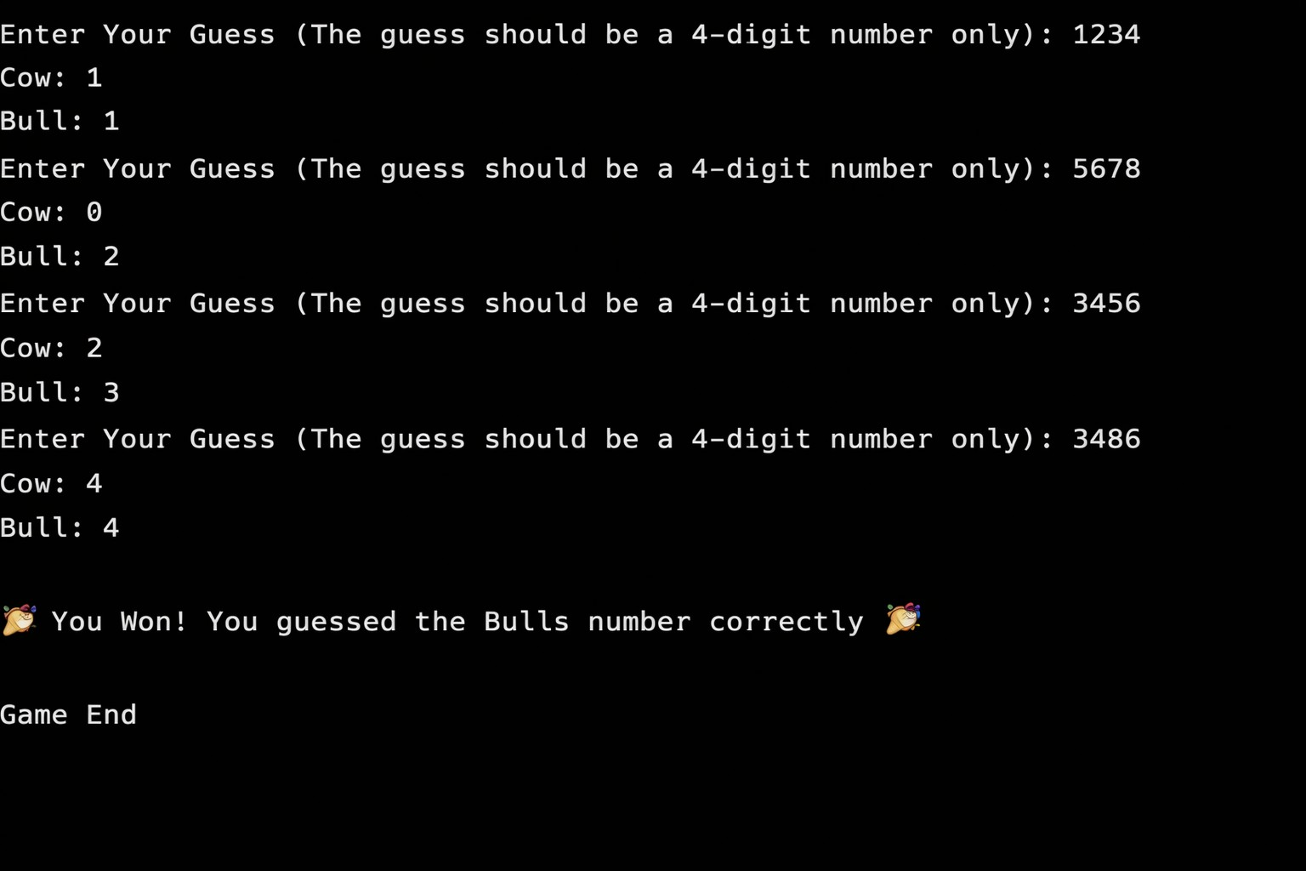

B.HANGMAN(Word guessing game)
Code:
#include <iostream>
using namespace std;
void Hangman(int wrong)
{
cout << "____\n";
cout << "| |\n";
if (wrong >= 1)
cout << "| O\n";
else
cout << "|\n";
if (wrong == 2)
cout << "| |\n";
else if (wrong == 3)
cout << "| / |\n";
else if (wrong >= 4)
cout << "| / | \\\n";
else
cout << "|\n";
if (wrong == 5)
cout << "| /\n";
else if (wrong >= 6)
cout << "| / \\\n";
else
cout << "|\n";
}
void playGame(string setter, string guesser)
{
string word;
string guess;
char letter;
int wrong;
bool found;
int i;
wrong = 0;
cout << setter << ", enter the word: ";
cin >> word;
for (i = 0; i < word.length(); i++) word[i] = tolower(word[i]);
guess = string(word.length(), '_');
system("cls");
cout << guesser << ", start guessing!\n";
while (wrong < 6 && guess != word)
{
Hangman(wrong);
cout << "\nWord: " << guess;
cout << "\nGuess a letter: ";
cin >> letter; letter = tolower(letter); found = false;
for (i = 0; i < word.length(); i++)
{
if (word[i] == letter && guess[i] == '_')
{
guess[i] = letter;
found = true;
}
}
if (found == false)
{
wrong++;
cout << "Wrong guess!\n";
}
else
{
cout << "Correct guess!\n";
}
system("pause");
cout << "\n--------------------\n";
}
Hangman(wrong);
if (guess == word)
cout << "\n let's go " << guesser << " WON! Word was: " << word << endl;
else
cout << "\n damnn " << guesser << " LOST! Word was: " << word << endl;
}
int main()
{
string player1; string player2;
cout << "Enter Player 1 name: ";
cin >> player1;
cout << "Enter Player 2 name: ";
cin >> player2;
cout << "\n--- ROUND 1 ---\n"; playGame(player1, player2);
cout << "\n--- ROUND 2 ---\n"; playGame(player2, player1);
cout << "\n**Game Over **\n";
return 0;
}
Output:

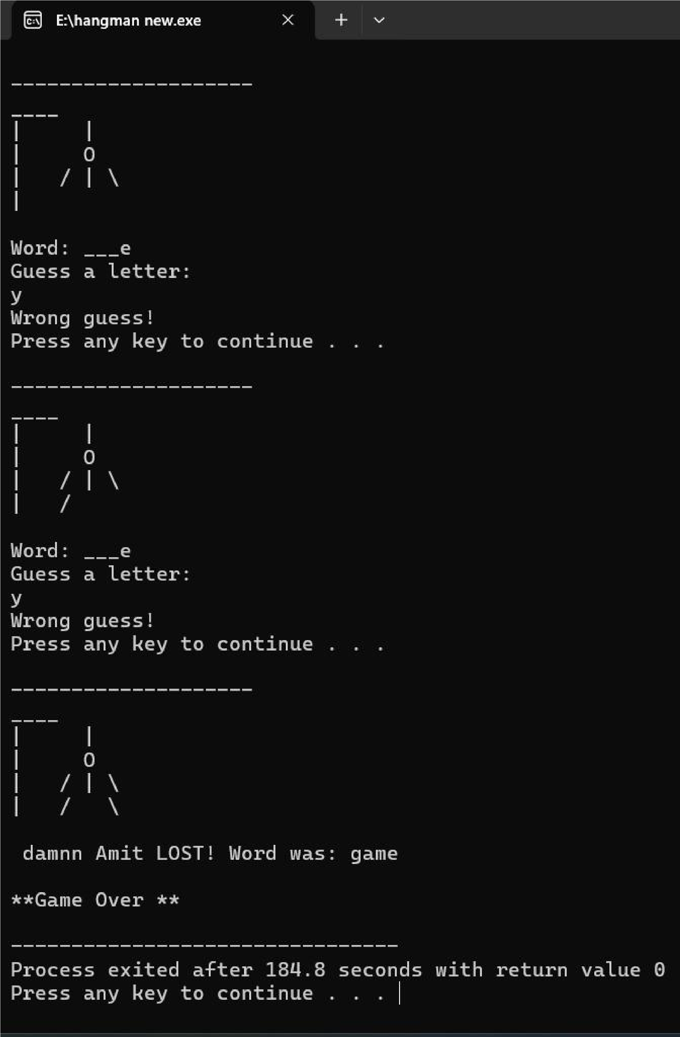

C.NUMBER GUESSING GAME
Code:
#include <iostream>
#include <cstdlib>
#include <ctime>
using namespace std;

int main() {
srand(time(0)); // Seed random number generator
int secretNumber = rand() % 100 + 1; // Random number between 1 and 100
int guess;
int attempts = 0;

cout << "🎯 Welcome to the Number Guessing Game!\n";
cout << " Welcome to RH game box \n";
cout << "Guess a number between 1 and 100:\n";
do {
cin >> guess;
attempts++;
if (guess > secretNumber) {
cout << "Too high! Try again:\n";
} else if (guess < secretNumber) {
cout << "Too low! Try again:\n";
} else {
cout<< " CONGRATULATION 🎉 Correct Answer! You guessed the number in "
<< attempts << " attempts.\n";
}
} while (guess != secretNumber);
return 0;
}
Output :
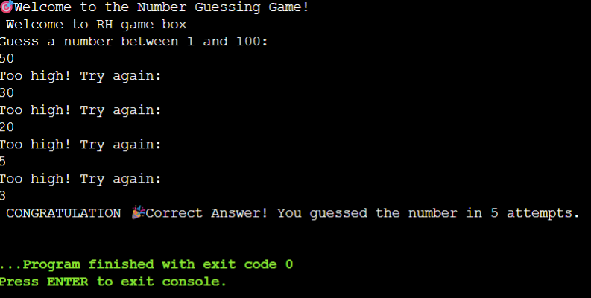

D.TIC TAC TOE
Code:
#include <iostream>
#include <string>
#include <conio.h>
#include <windows.h>
using namespace std;

// Global Variables
string box[9] = {"1","2","3","4","5","6","7","8","9"};
string player1, player2;
int choice;

// Function to draw game board
void GameBoard()
{
system("cls");
cout << "\n\n\n";
cout << " |-----|-----|-----|\n";
cout << " | " << box[0] << " | " << box[1] << " | " << box[2] << " |\n";
cout << " |-----|-----|-----|\n";
cout << " | " << box[3] << " | " << box[4] << " | " << box[5] << " |\n";
cout << " |-----|-----|-----|\n";
cout << " | " << box[6] << " | " << box[7] << " | " << box[8] << " |\n";
cout << " |-----|-----|-----|\n\n";
}

// Win condition check
bool checkWin()
{
int win[8][3] = {
{0,1,2},{3,4,5},{6,7,8},
{0,3,6},{1,4,7},{2,5,8},
{0,4,8},{2,4,6}
};

for(int i=0;i<8;i++)
{
if(box[win[i][0]] == box[win[i][1]] &&
box[win[i][1]] == box[win[i][2]])
return true;
}
return false;
}

// Check draw
bool checkDraw()
{
for(int i=0;i<9;i++)
if(box[i] != "X" && box[i] != "O")
return false;
return true;
}

// Main Function
int main()
{
HANDLE hConsole = GetStdHandle(STD_OUTPUT_HANDLE);

SetConsoleTextAttribute(hConsole, 10);
cout << "\n\n\n";
cout << " |------------------|\n";
cout << " | TIC TAC TOE |\n";
cout << " |------------------|\n\n";
SetConsoleTextAttribute(hConsole, 14);
cout << " Press any key to start...";
getch();

system("cls");

cout << "\n\nEnter Player 1 Name (X): ";
cin >> player1;
cout << "Enter Player 2 Name (O): ";
cin >> player2;

int turn = 0;

while(true)
{
GameBoard();

if(turn % 2 == 0)
{
cout << player1 << "'s turn (X): ";
cin >> choice;
choice--;

if(choice >= 0 && choice < 9 && box[choice] != "X" && box[choice] != "O")
box[choice] = "X";
else
continue;
}
else
{
cout << player2 << "'s turn (O): ";
cin >> choice;
choice--;

if(choice >= 0 && choice < 9 && box[choice] != "X" && box[choice] != "O")
box[choice] = "O";
else
continue;
}

if(checkWin())
{
GameBoard();
cout << "\n?? ";
cout << ((turn % 2 == 0) ? player1 : player2) << " Wins!\n";
break;
}

if(checkDraw())
{
GameBoard();
cout << "\n?? Game Draw!\n";
break;
}

turn++;
}

cout << "\nPress any key to exit...";
getch();
return 0;
}

Output: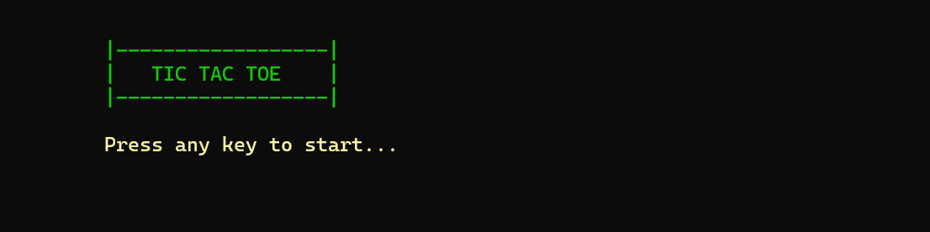
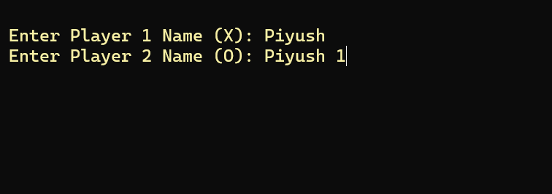
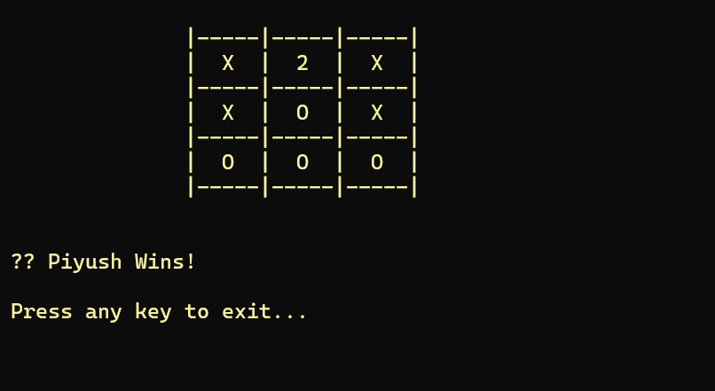

CHAPTER 5:CONCLUSION
5.1 Future Scope of the project:
* Enhanced graphics and sound
* Multiplayer options
* Mobile platform adaptation.

5.2 Limitations:
* Text-based interface.
* Limited AI complexity
* Basic scoring mechanisms.
5.3 Security:
* Data validation and input handling.
* User authentication for multiplayer features.
5.4 Conclusion:
The project successfully demonstrates the versatility of C++ through engaging games.

CHAPTER 6: BIBLIOGRAPHY
6.1 Books:
- Jeffery M. Cogswell, “C All-in-One For Dummies”
-Herbert Schildt, “C++: The Complete Reference”
-Bjarne Stroustrup, “Programming: Principles and Practice Using C++”
-Josee Lajoie and Stanley B. Lippman, “C++ Primer”
6.2 Websites:
-https://stackoverflow.com
-https://www.skillarger.com

